The Influence of Self-Efficacy and Social Support on Interest in Attending Cross-Department Lectures

Salsa Khalifatun Nisa¹, Firman², Robi Hendra³, Muhammad Qudwatie⁴, Mohamad Muspawi⁵
¹ Universitas Jambi, Jambi, Indonesia
² Universitas Jambi, Jambi, Indonesia
³ Universitas Jambi, Jambi, Indonesia
⁴ Malaya University, Kuala Lumpur, Malaysia
⁵ Universitas Jambi, Jambi, Indonesia

Article Info |  | ABSTRACT
Article history:  Received xx, xx, 2024  Revised xx, xx, 2024  Accepted xx, xx, 2024 |  | This study aims to analyze the influence of self-efficacy and social support on students' interest in participating in cross-major courses in the Independent Student Exchange Program (PMM) at Jambi University. The approach used is ex post facto with the PLS-SEM method, using SmartPLS 3.2.9, and involving 110 students as respondents. The research instrument consists of 34 statements covering the variables of self-efficacy (X1), social support (X2), and student interest (Y). The analysis results show that self-efficacy and social support significantly affect student interest. The reliability and validity tests show that all constructs meet the standards with a Cronbach’s Alpha value above 0.9. These findings confirm that self-efficacy and social support play a crucial role in increasing students' interest in cross-departmental courses. Higher education institutions need to strengthen these two factors to increase student participation in interdisciplinary academic programs.
Keywords:
Self-efficacy; Social Support; Interest; Cross-Department Courses; Student Exchange; SmartPLS
 |  | 
Corresponding Author: salsaca04@gmail.com

INTRODUCTION
Higher education in Indonesia is undergoing significant changes in line with the demands of globalization. One of the main initiatives is the Merdeka Belajar-Kampus Merdeka (MBKM) policy developed by the Ministry of Education, Culture, Research, and Technology. This policy aims to increase the flexibility of student learning, one of which is through the Merdeka Student Exchange Program (PMM), which provides opportunities for students to take courses at other universities, including outside their original study programs (Kemdikbud, 2020a). This policy provides students with the flexibility to enrich their learning experiences, especially through the Independent Student Exchange Program (PMM) (Kemdikbud, 2020b). This program gives students the opportunity to explore new fields of knowledge, encourages cross-cultural interactions, and expands professional networks. By participating in PMM, students can develop soft skills, such as communication, cooperation, and adaptation, which are important in today's job market.
At Jambi University, observational data shows that out of 497 participating PMM students, only 185 students (37.23%) chose to take courses in different departments. This indicates that although PMM offers extensive opportunities for academic exploration, students' interest in taking cross-department courses remains low before the program begins. Several factors, such as a lack of academic self-efficacy and limited information, play a role in their decision-making. Strong social support has been proven to enhance academic success and student well-being (Malecki & Demaray, 2006). Therefore, students who receive adequate support are more interested in taking cross-department courses because they feel motivated.
According to Hidi and Ann Renninger (2006), the development of student interest occurs in several stages, starting from situationally triggered interest to deeper individual interest. However, in the PMM program at Jambi University, there is still uncertainty in maintaining students' interest in cross-major courses, which affects their satisfaction and study continuity. Moreover, self-efficacy and social support are important factors that can influence students' interest in taking cross-department courses. As emphasized by Schunk and DiBenedetto (2020), internal factors such as self-efficacy play an important role in enhancing students' motivation and interest in achieving academic goals.
Based on the various issues that have been outlined, it can be concluded that self-efficacy and social support play important roles in shaping and maintaining students' interest in participating in cross-major courses in the Independent Student Exchange Program (PMM). However, the low initial interest, academic uncertainty, and various obstacles faced by students indicate the need for further study on the factors influencing that interest. Therefore, the researcher is interested in further investigating the "Influence of Self-Efficacy and Social Support on Interest in Attending Cross-Department Classes in Pertukaran Mahasiswa Merdeka Program (PMM) at Jambi University."

METHODS
This research uses a quantitative approach with an ex post facto design. This approach was chosen because the research was conducted on variables that had occurred without any intervention or treatment from the researcher. According to Widarto (2018), ex post facto research is a type of research that collects and analyzes data based on events that have occurred previously. In this study, data is collected to understand the relationships between variables without manipulating the variables being studied, thus allowing for an objective analysis of the phenomena that have occurred.

Data Collection Instruments and Conceptual Framework
Data collection was conducted using a questionnaire instrument designed in two parts. The first part contains questions related to the respondents' demographic information, while the second part consists of 34 statements covering several research constructs. The self-efficacy construct is adapted from (Febrian, 2022; Hasfi, 2018; Nurhalimah, 2021), which consists of Master Experience (SME) (3 items), Vicarious Experience (SVE) (1 item), Social Persuasion (SSP) (2 items), and Physiological State (SPS) (4 items). Meanwhile, the social support construct encompasses five aspects, namely Emotional Support (DNB) (2 items), Appraisal Support (DHA) (2 items), Instrumental Support (DBT) (3 items), Informational Support (DNS) (3 items), and Social Network Support (DSP) (2 items). The variable of students' interest in cross-departmental courses consists of four constructs, namely Enjoyment (MPS) (3 items), Attention in Activities (MPA) (3 items), Interest (MKR) (3 items), and Engagement (MKL) (3 items). All items in the questionnaire were measured using a Likert scale with five levels of assessment: strongly agree, agree, neutral, disagree, and strongly disagree. This questionnaire was then distributed and tested on 110 students, resulting in Cronbach’s Alpha values for each variable as follows: Self-Efficacy (X1) at 0.937, Social Support (X2) at 0.949, and Interest in Specialization (Y) at 0.933, indicating high reliability.
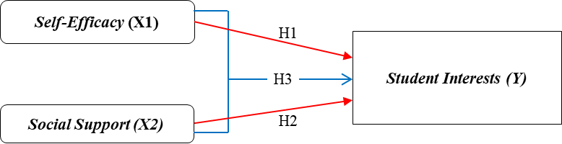
Figure 1. Conceptual Framework
The image above shows that the red arrows illustrate the partial influence of variables X1 and X2 on the dependent variable (Y). Meanwhile, the blue arrows indicate that variables X1 and X2 simultaneously influence the dependent variable (Y).

Data and Sample Collection
This research involved 110 students as respondents, with data collection carried out through a Google Form-based questionnaire. The collected data were then analyzed using Cronbach’s Alpha to evaluate reliability, mean, and standard deviation, thereby understanding the descriptive statistics of the respondents as well as the relationships between the variables studied. Additionally, an analysis was conducted to identify the factors that have the greatest influence on students' interest in taking cross-department courses. In determining the appropriate sample size, this study uses the G*Power application to analyze the sample strength. The sampling technique applied is non-probability sampling with the purposive sampling method, which is the selection of samples based on specific criteria set by the researcher. The inclusion criteria used are students from Jambi University who are participants of the PMM cohort 3 for the 2023/2024 academic year and meet the requirements and are willing to participate in the research. The results of the calculation with G*Power show that a sample size of 110 respondents has achieved an analysis power of 0.95. Next, data processing was carried out using SmartPLS version 3.2.9 software with the SEM-PLS approach. The stages of analysis include model testing, which encompasses reliability and construct validity tests, as well as structural model assessment, which evaluates the relationships between variables both partially and simultaneously.

FINDINGS AND DISCUSSION
Findings
Description of Research Data
Table 1. Demographic Profile of Participants
Variables | Demographics | Frequency (N-110) | Percentage | Mean
Age | <20 Years | 28 | 25 | 1,745
Age | >20 Years | 82 | 75 | 1,745
Age | Total | 110 | 100 | 1,745
Gender | Man | 31 | 28 | 1,718
Gender | Women | 79 | 72 | 1,718
Faculty | FKIP | 35 | 32 | 2,809
Faculty | FEB | 27 | 25 | 2,809
Faculty | FH | 14 | 13 | 2,809
 | FST | 13 | 12 | 2,809
 | FAPET | 4 | 4 | 2,809
 | FAPERTA | 13 | 12 | 2,809
 | FKIK | 4 | 4 | 2,809
Generation | 2020 | 5 | 5 | 2,236
 | 2021 | 74 | 67 | 2,236
 | 2022 | 31 | 28 | 2,236
Tables 1 and 2 present the results of descriptive statistics regarding the demographics of the students who participated as respondents in this study. Based on age groups, the students are divided into two categories: < 20 years old with 28 people (25%) and > 20 years old with 82 people (75%). If viewed by gender, there are 31 male students (28%) and 79 female students (72%). In terms of the faculty of origin, the respondents come from various faculties, namely FKIP with 35 people (32%), FEB with 27 people (25%), FH with 14 people (13%), FST with 13 people (12%), FAPET with 4 people (4%), FAPERTA with 13 people (12%), and FKIK with 4 people (4%). Based on the cohort, students from the 2020 cohort numbered 5 people (5%), the 2021 cohort 74 people (67%), and the 2022 cohort 31 people (28%). Meanwhile, when viewed based on the destination universities, the number of students participating in the program at Universitas Pembangunan Nasional Veteran Jawa Timur is 12 people (11%), Universitas Pendidikan Indonesia 10 people (9%), Universitas Padjadjaran 8 people (7%), Universitas Sultan Ageng Tirtayasa 6 people (5%), and Universitas Tribhuwana Tungga Dewi 5 people (5%). Other universities have a respondent count below 5%.
Table 2. Demographic Profile of Participants (Based on Destination University)
Variables | Demographics | Frequency | Percentage | Mean
Destination University | Univ. Jember | 2 | 2 | 16.818
Destination University | Univ. Padjadjaran | 8 | 7 | 16.818
Destination University | Univ. Permangunan Nasional Veteran Jawa Timur | 12 | 11 | 16.818
Destination University | Univ. Pendidikan Indonesia | 10 | 9 | 16.818
Destination University | Univ. Negeri Makassar | 2 | 2 | 16.818
Destination University | Univ. Tribhuwana Tungga Dewi | 5 | 5 | 16.818
Destination University | Univ. Mataram | 1 | 1 | 16.818
Destination University | Univ. Sebelas Maret | 2 | 2 | 16.818
Destination University | Univ. Sultan Ageng Tirtayasa | 6 | 5 | 16.818
Destination University | Univ. Khairun | 2 | 2 | 16.818
Destination University | Univ. Pendidikan Muhammadiyah Sorong | 2 | 2 | 16.818
Destination University | Univ. Fajar | 3 | 3 | 16.818
Destination University | Univ. Kuningan | 3 | 3 | 16.818
Destination University | Univ. Bosowa | 2 | 2 | 16.818
Destination University | Univ. Airlangga | 2 | 2 | 16.818
Destination University | Univ. Pasundan | 3 | 3 | 16.818
Destination University | Univ. PGRI Yogyakarta | 1 | 1 | 16.818
Destination University | Univ. Pendidikan Ganesha | 3 | 3 | 16.818
Destination University | Institut Pertanian Bogor | 1 | 1 | 16.818
Destination University | Univ. Negeri Yogyakarta | 1 | 1 | 16.818
Destination University | Univ. Negeri Gorontalo | 3 | 3 | 16.818
Destination University | Univ. Amikom Purwokerto | 2 | 2 | 16.818
Destination University | Institut Teknologi Bandung | 1 | 1 | 16.818
Destination University | Univ. Gadjah Mada | 1 | 1 | 16.818
Destination University | Univ. Sarjanawiyata Tamansiswa | 1 | 1 | 16.818
Destination University | Univ. Musamus Merauke | 1 | 1 | 16.818
Destination University | Univ. Negeri Malang | 1 | 1 | 16.818
Destination University | Univ. Muhammadiyah Malang | 2 | 2 | 16.818
Destination University | Univ. Al-Azhar Indonesia | 2 | 2 | 16.818
Destination University | Univ. Merdeka Malang | 2 | 2 | 16.818
Destination University | Univ. Islam Makassar | 2 | 2 | 16.818
Destination University | Univ. Lambung Mangkurat | 1 | 1 | 16.818
Destination University | Univ. Tidar | 1 | 1 | 16.818
Destination University | Sekolah Tinggi Ilmu Ekonomi Malangkucecwara | 2 | 2 | 16.818
Destination University | Univ. Pamulang | 2 | 2 | 16.818
Destination University | Univ. PGRI Semarang | 1 | 1 | 16.818
Destination University | Univ. Hasanuddin | 1 | 1 | 16.818
Destination University | Univ. Pattimura | 1 | 1 | 16.818
Destination University | Univ. Islam Malang | 1 | 1 | 16.818
Destination University | Univ. Warmadewa | 2 | 2 | 16.818
Destination University | Univ. Kristen Indonesia | 1 | 1 | 16.818
Destination University | Sekolah Tinggi Ilmu Kesehatan Papua | 1 | 1 | 16.818
Destination University | Univ. Muhammadiyah Makassar | 1 | 1 | 16.818
Destination University | Univ. Islam Sultan Agung | 1 | 1 | 16.818
Destination University | Univ. PGRI Madiun | 1 | 1 | 16.818
Destination University | Univ. Ahmad Dahlan | 1 | 1 | 16.818
Destination University | Univ. Muhammadiyah Semarang | 1 | 1 | 16.818
Destination University | Univ. Nahdlatul Ulama Surabaya | 1 | 1 | 16.818
Destination University | University Surabaya | 1 | 1 | 16.818
 | Total | 110 | 100%

Data Analysis
The PLS-SEM equation model was chosen in this study because it has good predictive capabilities and is suitable for data analysis and hypothesis testing conducted using Smart PLS software. The PLS-SEM technique is applied to develop a model of the relationship between factors influencing student interest (Damayanti & Kurniawan, 2021), where the researcher will consider several factors in this analysis. To ensure that the design or model produced in Smart PLS is optimal, a validation test is conducted to ensure that the instrument can measure the variables well. In this study, validity is tested using convergent validity and discriminant validity methods with the help of Smart PLS 3.2.9. In addition, data collection was conducted using Google Form. After the data is obtained, the analysis begins by uploading the file in CSV (comma-separated values) format into the Smart PLS software, and then the data is analyzed through the following stages:
Table 3. Statistical Description of the Questionnaire (Between construct items) (Anggadwita et al., 2022)
Construct  (Indicator) | Coding | Statement (items) | Mean | Loading | VIF | Ave | R-Square | Cronbach's
Master Experience (SME) | SME1 | I use my previous learning experiences to help me succeed in cross-disciplinary studies. | 3.818 | 0.759 | 2.331 | 0.667 |  | 0.937
 | SME3 | The experience of completing previous assignments makes me confident that I can succeed in cross-major studies. | 4.382 | 0.777 | 2.583 | 0.667 |  | 0.937
Vicarious Experience (SVE) | SVE1 | The experiences of other students give me the confidence that I can also succeed in cross-department studies. | 4.055 | 0.823 | 2.960 | 0.667 |  | 0.937
Social Persuasion (SSP) | SSP1 | I am more confident because of the encouragement from my professor. | 4.245 | 0.870 | 4.473 | 0.667 |  | 0.937
Social Persuasion (SSP) | SSP2 | Positive comments from professors, friends, and family boost my confidence. | 4.227 | 0.855 | 3.354 | 0.667 |  | 0.937
Physiological State (SPS) | SPS1 | I am able to handle pressure when facing challenges in cross-departmental courses. | 3.782 | 0.783 | 2.537 | 0.667 |  | 0.937
Physiological State (SPS) | SPS2 | I don't easily get stressed when facing difficulties in cross-department courses. | 3.755 | 0.825 | 3.336 | 0.667 |  | 0.937
Physiological State (SPS) | SPS3 | I remain calm and confident when facing challenges in cross-departmental courses. | 4.045 | 0.829 | 2.805 | 0.667 |  | 0.937
Physiological State (SPS) | SPS4 | My physical and emotional condition supports me in taking cross-department courses. | 4.127 | 0.821 | 2.509 | 0.667 |  | 0.937
Emotional Support (DNB) | DNB1 | I am comfortable sharing cross-major study plans with friends. | 4.327 | 0.790 | 2.635 | 0.643 |  | 0.949
Emotional Support (DNB) | DNB2 | The support from friends makes me feel noticed when discussing cross-department courses. | 3.881 | 0.819 | 2.971 | 0.643 |  | 0.949
Support Recognition (DHA) | DHA1 | The professor's acknowledgment of my plan boosts my motivation. | 4.254 | 0.780 | 2.689 | 0.643 |  | 0.949
Support Recognition (DHA) | DHA2 | I feel appreciated when my family supports my decision. | 4.054 | 0.787 | 2.701 | 0.643 |  | 0.949
Instrumental Support (DBT) | DBT1 | Friends are helping me find information about cross-department courses. | 4.109 | 0.818 | 3.741 | 0.643 |  | 0.949
Instrumental Support (DBT) | DBT2 | I received real help from the contact person at my sending university to complete the program procedure. | 3.854 | 0.833 | 4.631 | 0.643 |  | 0.949
Instrumental Support (DBT) | DBT3 | The lecturer helped me understand the procedures for cross-department programs/courses. | 4.027 | 0.837 | 4.407 | 0.643 |  | 0.949
Information Support (DNS) | DNS1 | The advice from the sending campus PIC was very helpful to me. | 3.727 | 0.773 | 2.692 | 0.643 |  | 0.949
Information Support (DNS) | DNS2 | The professor's advice about the right course encouraged me to take cross-department classes. | 4.154 | 0.806 | 3.570 | 0.643 |  | 0.949
Information Support (DNS) | DNS3 | The positive feedback from friends who have taken cross-department courses gives me confidence. | 3.927 | 0.823 | 3.584 | 0.643 |  | 0.949
Social Network Support (DSP) | DSP1 | Being together with friends makes me more motivated. | 3.918 | 0.806 | 3.039 | 0.643 |  | 0.949
Social Network Support (DSP) | DSP2 | My friends and I trust each other to support one another. | 3.654 | 0.747 | 2.455 | 0.643 |  | 0.949
Feeling Happy (MPS) | MPS1 | I am excited to discuss cross-department study plans with my friends. | 4.055 | 0.743 | 1.996 | 0.626 | 0.782 | 0.933
Feeling Happy (MPS) | MPS2 | I enjoy imagining taking courses outside my major. | 3.855 | 0.829 | 3.148 | 0.626 | 0.782 | 0.933
Feeling Happy (MPS) | MPS3 | I increasingly want to join after knowing the benefits of taking cross-department courses. | 3.655 | 0.753 | 2.535 | 0.626 | 0.782 | 0.933
Attention in Activities (MPA) | MPA2 | I keep up with the latest information about cross-major study opportunities. | 3.718 | 0.781 | 2.613 | 0.626 | 0.782 | 0.933
Attention in Activities (MPA) | MPA3 | I am actively looking for information on cross-major courses that match my interests. | 3.764 | 0.784 | 2.521 | 0.626 | 0.782 | 0.933
Excited (MKR) | MKR1 | I am interested in the courses at the host university. | 4.064 | 0.803 | 2.869 | 0.626 | 0.782 | 0.933
 | MKR3 | I am interested in exploring knowledge beyond my major. | 3.891 | 0.817 | 3.032 | 0.626 | 0.782 | 0.933
Involvement (MKL) | MKL1 | I actively participate in discussions and cross-departmental college activities. | 4.100 | 0.832 | 3.526 | 0.626 | 0.782 | 0.933
Involvement (MKL) | MKL2 | I often get involved in group assignments or projects given in interdisciplinary courses. | 4.191 | 0.830 | 3.161 | 0.626 | 0.782 | 0.933
Involvement (MKL) | MKL3 | I feel involved in every academic activity related to cross-department courses. | 3.982 | 0.730 | 1.942 | 0.626 | 0.782 | 0.933

Based on the table above, the highest mean score of 4.3 is found in the self-efficacy variable with the Master Experience (SME) construct and in the social support variable with the Emotional Support (DNB) construct. Meanwhile, the lowest mean score of 3.6 was found in the interest variable with the Happy Feeling construct (MPS) and in the social support variable with the Social Network Support construct (DSP).
Table 4. Statistical Description of the Questionnaire (Between Variables)
SELF-EFFICACY |  | SOCIAL SUPPORT |  | INTEREST
Mean | 40.481 | Mean | 47.890 | Mean | 47.127
Standard Deviation | 7.810 | Standard Deviation | 9.591 | Standard Deviation | 9.578
Minimum | 10 | Minimum | 12 | Minimum | 12
Maximum | 50 | Maximum | 60 | Maximum | 60
Count (N) | 110 | Count (N) | 110 | Count (N) | 110
Based on the descriptive statistical results (by variable) presented in Table 4, the analysis of 110 respondents shows that the self-efficacy variable has an average of 40.48 with a standard deviation of 7.81. Meanwhile, the social support variable recorded an average of 47.89 with a standard deviation of 9.59. The variable of student interest in attending cross-departmental lectures has an average value of 47.12 with a standard deviation of 9.57.

Evaluation of the Measurement Model (Outer Model)
The reliability of indicators aims to test the extent to which the indicators can be relied upon to measure latent variables. Evaluation is conducted by examining the outer loading values of each indicator. If the loading value is more than 0.7, then the construct can explain more than 50% of the variance of the variable it measures (Hair Jr. et al., 2017). In this study, most of the outer loading values exceed 0.7, while only three indicators have values below 0.7 (SME2, MPA1, and MKR2). All outer loading values greater than 0.7 have been displayed in the previous table. Convergent validity is determined based on the principle that indicators measuring the same construct should have a high correlation (Hair et al., 2011). Convergent validity is evaluated through Average Variance Extracted (AVE), where the AVE value must reach at least 0.5 or higher. This indicates that the construct can explain at least 50% of the variance of each item it measures (J. Hair et al., 2017).
In SmartPLS, reliability testing is conducted using two methods, namely Cronbach’s Alpha and Composite Reliability. Hair Jr. et al. (2017) state that composite reliability and Cronbach’s Alpha, which are calculated together with AVE, are used to evaluate the reliability of the model. The ideal values for composite reliability and Cronbach’s Alpha are above 0.7, although a value of 0.6 is still acceptable. However, this internal consistency testing is not absolute, because although a valid construct is certainly reliable, a reliable construct is not necessarily valid. In this study, the composite reliability values range from 0.943 to 0.956, while the AVE values range from 0.626 to 0.667. These results indicate that all indicators in the study have met the standards of validity and reliability. The correlation between the indicator and the construct it measures is considered very high if the correlation value is more than 0.70. In the early stages of research scale development, a value range between 0.50 and 0.60 is still considered quite adequate.
Discriminant validity aims to ensure that reflective indicators truly measure their construct well. The main principle of discriminant validity is that each indicator must have a strong correlation with the construct it measures, while the correlation with other constructs should not be too high (Hair Jr. et al., 2017). In the SmartPLS 3.2.9 application, discriminant validity testing is conducted using cross-loading, the Fornell-Larcker Criterion, and the Heterotrait-Monotrait Ratio (HTMT) (Henseler et al., 2015).
In the traditional approach (traditional view), the Fornell-Larcker method is considered the main standard for testing discriminant validity in PLS-PM. However, recent research (up-to-date view) by Henseler et al., (2015) shows that HTMT is more accurate and more reliable, so HTMT is now more frequently used in studies applying PLS-SEM. This is due to the limitations of Fornell-Larcker, which relies on consistent factor loading estimates, potentially resulting in less accurate evaluations of discriminant validity. Therefore, HTMT was developed as a more effective and reliable alternative in detecting potential discriminant validity issues in PLS-SEM models.
The evaluation of cross-loading values for each construct is conducted to ensure that the correlation between the construct and its measurement indicators is higher compared to its correlation with other constructs. According to Hair et al. (2017), the expected cross-loading value must be greater than 0.7. Based on the results of the statistical test conducted with the help of the SmartPLS application, Table 2 shows that the cross-loading values for each construct in this study exceed 0.7. Thus, all the research items used have met the instrument validity requirements. In addition, the measurement of discriminant validity was also conducted using the Heterotrait-Monotrait Ratio (HTMT) procedure through the SmartPLS application, and the results can be seen in the following table 5:
Table 5. Rasio Heterotrait-Monotrait
 | SELF-EFFICACY (X1) | SOCIAL SUPPORT (X2) | INTEREST (Y)
SELF-EFFICACY (X1)
SOCIAL SUPPORT (X2) | 0.858
INTEREST (Y) | 0.895 | 0.893
Some experts argue that cross-loading and the Fornell-Larcker criterion have limitations in accurately detecting discriminant validity. Therefore, the Heterotrait-Monotrait Ratio (HTMT) method is recommended as an alternative to evaluate discriminant validity. This method is based on a multi-trait multi-method matrix in its measurement process. According to Henseler et al., (2015), the HTMT value must be less than 0.9 for the discriminant validity between two reflective constructs to be acceptable. Based on the analysis results in the table above, all obtained HTMT values are below 0.9, so it can be concluded that the research instruments used have met the discriminant validity and are suitable for use in this study.

Evaluation of the Structural Model (Inner Model)
Variance Inflation Factor (VIF) is used to assess data alignment by detecting the presence of multicollinearity. Multicollinearity occurs when two or more independent variables have a very high correlation, which can weaken the predictive ability of the model. According to Hair et al., (2020), the VIF value should be less than 5, because if it exceeds that number, it indicates collinearity between constructs. The measurement of multicollinearity in this study was conducted using VIF, as shown in Table 3 regarding the Measurement Model and Construct Validity. If the VIF value is more than 5.0, then there is a problem with the model's linearity (J. F. Hair et al., 2017). However, the results of this study indicate that there are no VIF values exceeding 5.0 (Table 3), thus it can be concluded that there are no significant multicollinearity issues in this study.
The coefficient of determination (R²) is used to assess the extent to which the endogenous variable can be explained by the exogenous variable in a model. The R² value ranges from 0 to 1, with categories of 0.75 as strong, 0.50 as moderate, and 0.25 as weak (Hair Jr. et al., 2017). Meanwhile, according to Hair et al., (2020), the R² criteria are 0.67 (strong), 0.33 (moderate), and 0.19 (weak). In this study, the obtained R² value is displayed in Table 4, which shows that the model has a strong explanatory power in depicting the influence of self-efficacy (X1) and social support (X2) on students' interest in taking cross-departmental courses (Y). In addition, cross-validated redundancy (Q²) is used to assess the predictive relevance of the model. If the Q² value is greater than 0, then the model is considered to have good predictive relevance for a certain construct. On the other hand, if the Q² value is less than 0, the model is considered to have no predictive relevance (J. F. Hair et al., 2017). The measurement results using cross-validated redundancy (Q²) in this study can be seen in the following table 6;
Table 6. Cross-validated redundancy (Q2)
 | SSO | SSE | Q² (=1-SSE/SSO)
Self-Efficacy (X1) | 990.000 | 990.000
Social Support (X2) | 1320.000 | 1320.000
Interest (Y) | 1100.000 | 585.158 | 0.468

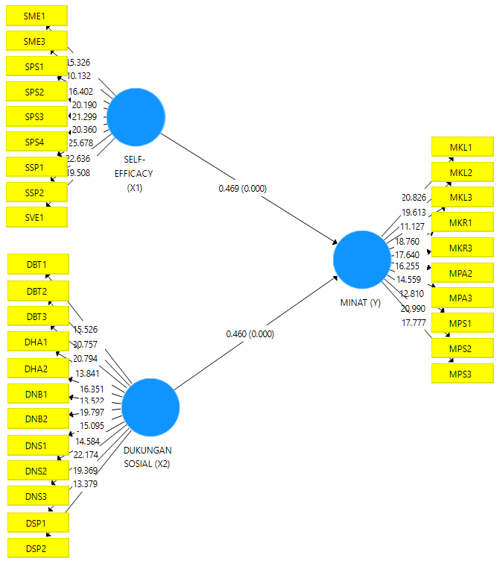
Figure 2. Outer Model Partial Influence Display

Figure 2 above displays the measurement model output that illustrates the partial influence of each research variable, namely self-efficacy and social support, on students' interest in taking cross-department courses, both partially. For a more detailed analysis regarding the direct effects, including Mean values, Standard Deviation (STDEV), T-Values, and P-Values, please refer to Tables 7 and 8 below;

Table 7. Summary of Hypothesis Testing Results
Hypothesis | Path Coefficient | P Value
H1 : Self-Efficacy (X1) -> Cross-Departmental Interests  (Y) | 0.469 | 0.000 | Supported
H2 : Social Support (X2) -> Cross-Departmental Interests (Y) | 0.460 | 0.000 | Supported

This data provides an in-depth overview of the extent to which each variable contributes to student interest in cross-departmental programs.
Table 8. Hypothesis Testing Details
 | Original Sample (O) | Sample Average (M) | Standard Deviation (STDEV) | T Statistic (| O/STDEV |) | P Values
Self-Efficacy (X1) -> Student Interests (Y) | 0.469 | 0.466 | 0.099 | 4.751 | 0.000
Social Support (X2) -> Student Interests (Y) | 0.460 | 0.464 | 0.099 | 4.647 | 0.000

Table 9. Summary of Simultaneous Hypothesis Testing Results
Hypothesis | R Square | Adjusted R Square
H3 : Self-Efficacy (X1), Social Support (X2) -> Cross-Departmental Interests (Y) | 0.782 | 0.778 | Supported

Table 10. Details of Simultaneous Influence (R Square)
 | R Square | Adjusted R Square
INTEREST (Y) | 0.782 | 0.778

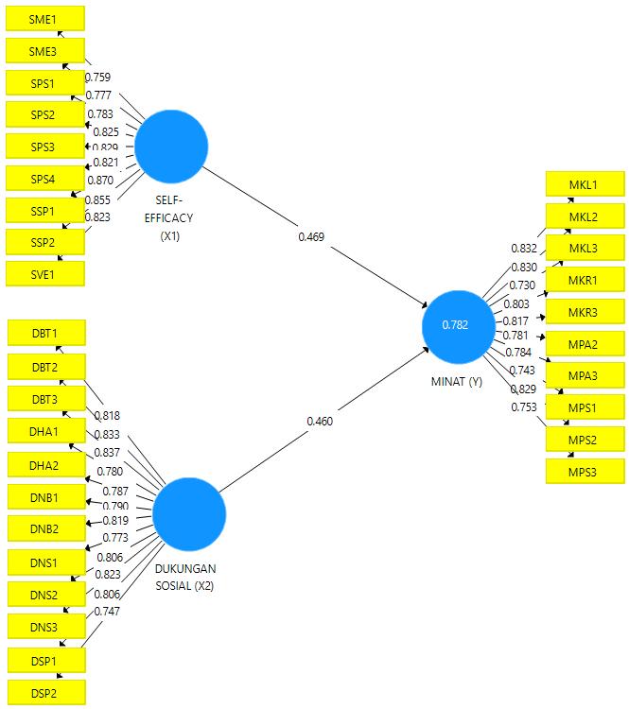
Figure 3. Outer Model Display of Simultaneous Influence
Table 10 above shows that the coefficient of determination value for student interest is 0.782, which is categorized as strong.
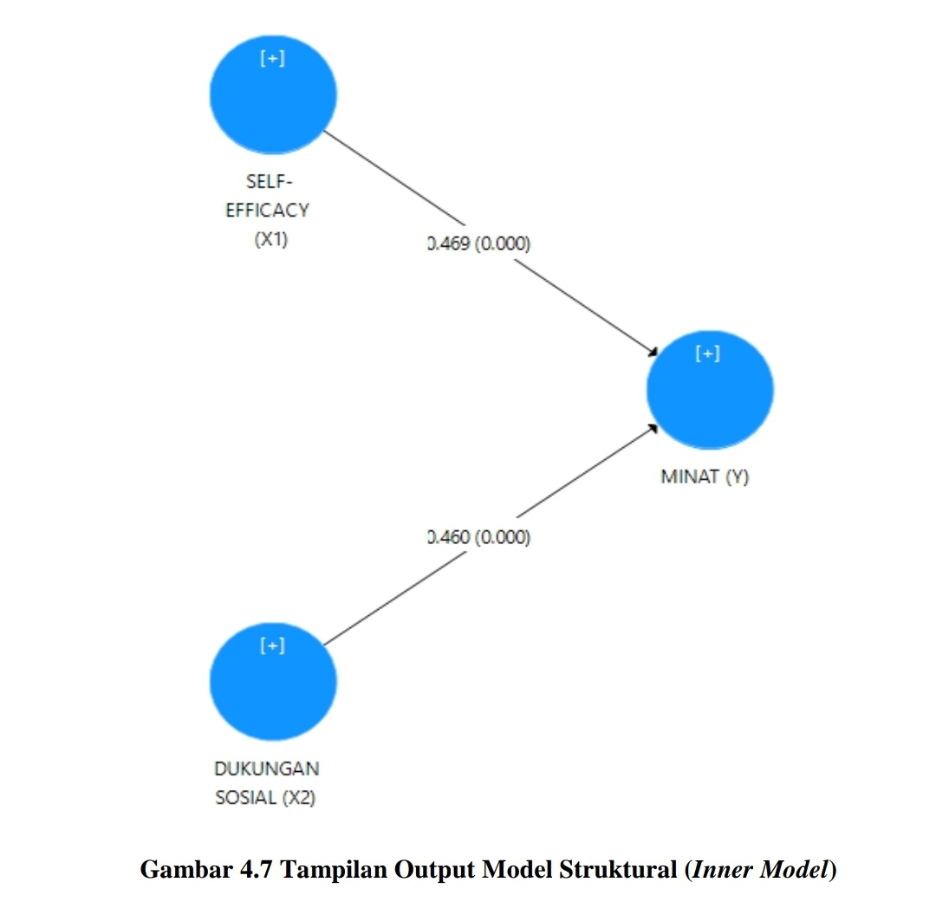
Figure 4. Inner Model / Hypothesis Display

Discussion
This research aims to analyze the influence of self-efficacy and social support on the interest of Jambi University students in taking cross-department courses. To achieve this objective, the research collected data from 110 students as a sample. Through this sample, the researchers evaluate the extent to which each variable, namely self-efficacy and social support, influences students' interest in choosing courses outside their original study programs. In this study, three hypotheses were proposed to examine the relationship between these variables. The results of the analysis show that all hypotheses were accepted, which means that self-efficacy and social support have a significant influence on students' interest in taking cross-department courses. All these findings have been formulated based on the previously established research questions, and are supported by relevant statistical analyses.

Self-efficacy towards Student Interest
The analysis results show that self-efficacy has a significant influence on students' interest in taking cross-department courses with an original sample value of 0.469 (positive direction), meaning that if X increases, Y also increases. The P-value of 0.000, which is less than 0.05, and the t-statistic of 4.751 (4.751 > 1.96) indicate that the influence is positive and statistically significant. Thus, the alternative hypothesis (Ha) is accepted, while the null hypothesis (H0) is rejected.
These findings are in line with the self-efficacy theory proposed by Bandura (1997), which states that self-efficacy is an individual's belief in their ability to complete specific tasks. In this study, students with high self-efficacy tend to be more confident in facing new academic challenges, including taking cross-department courses. In addition, the theory by Schunk dan DiBenedetto (2020) emphasizes that self-efficacy plays an important role in enhancing students' motivation and interest in achieving their academic goals.
This research also supports Zimmerman (2000), who revealed that self-efficacy influences students' academic choices and perseverance in learning. Previous research by Hanim dan Puspasari (2021) and Rikha dan Pamungkas (2023) supports this finding, where students with high self-efficacy tend to be more courageous and enthusiastic in exploring new academic opportunities. Students with high self-efficacy tend to have better academic performance because they are more motivated in facing challenges (Hendra et al., 2024).
In the Interest Development theory by Hidi dan Renninger (2006), interest can develop through a combination of internal factors such as self-efficacy. Therefore, enhancing students' self-efficacy becomes an important strategy to encourage their participation in cross-departmental programs. Factors such as personal experience, social persuasion, and confidence in facing difficulties become the main indicators of self-efficacy that influence student interest. When students feel confident in their abilities, they are more motivated to explore academic opportunities beyond their original study programs.

Social Support for Student Interest
Based on the analysis results, social support has a significant influence on student interest with an original sample value of 0.460 and a t-statistic value of 4.647 exceeding the t-table value of 1.96 (4.647 > 1.96), which means the influence of variable X1 on Y is positive (unidirectional), meaning if X increases, Y also increases. The P-value of 0.000 indicates that this influence is statistically significant. Thus, the alternative hypothesis (Ha) is accepted, and the null hypothesis (H0) is rejected. Social support from family, friends, and educational institutions plays an important role in enhancing students' self-confidence, comfort, and motivation to participate in cross-departmental programs. These findings are consistent with the research of Malecki dan Demaray (2006), which shows that social support can enhance psychological well-being and academic achievement.
Research by Putri dan Trisnawati (2022) also emphasizes that instrumental support significantly contributes to increasing students' interest in learning. Furthermore, Damanik dan Sugiarti (2023) found that social support strengthens psychological well-being, which positively impacts students' motivation and interest in exploring new academic opportunities. In the PMM program, social support helps students face challenges such as adapting to a new academic environment or uncertainty in choosing courses. With adequate support, students are more motivated to take significant steps in their personal development, including exploring cross-departmental programs.

Self-efficacy and Social Support towards Student Interest
The research results show that self-efficacy and social support simultaneously have a significant influence on students' interest in taking cross-department courses, with an R Square value of 0.782 or 78.2%. This means that, simultaneously, these two variables explain most of the variability in student interest. These results support the Interest Development theory by Renninger dan Hidi (2016), which states that interest develops through a combination of internal factors (self-efficacy) and external factors (social support). Lent dan Brown (2019) research also shows that the combination of self-efficacy and social support significantly impacts students' academic achievement and motivation. In the PMM program, students who have high self-confidence and adequate social support are better able to face academic challenges and are motivated to explore cross-departmental programs.
Elisa et al., (2020) research shows that the combination of these two factors not only increases motivation but also helps students overcome academic obstacles, such as lack of information or coordination between study programs. Additionally, Firman et al., (2019) highlight that cognitive growth helps individuals evaluate various suitable options. Self-efficacy influences perseverance in achieving goals, where self-efficacy also plays an important role in maintaining enthusiasm and dedication in every action taken. The results of this study emphasize the importance of self-efficacy and social support in increasing students' interest in participating in cross-departmental programs. Educational institutions, family, and friends play an important role in providing the necessary support to ensure the success of this program. Consistent support can help students overcome existing obstacles, making them more confident and motivated to explore available academic opportunities.

CONCLUSION
Based on the results of the analysis and hypothesis testing, this study shows that self-efficacy has a significant influence on students' interest in participating in cross-departmental courses, with a P Value of 0.000 and an Original Sample of 0.469 (positive) with a t-statistic of 4.751 (4.751 > 1.96). This indicates that the higher the self-efficacy of students, the greater their interest in participating in the program, thus the university needs to support the development of students' self-confidence through training, guidance, and supportive learning experiences. Additionally, social support has also been shown to have a significant impact on students' interest, with a P Value of 0.000 and an Original Sample of 0.460 (positive) with a t-statistic value of 4.647 exceeding the t-table of 1.96 (4.647 > 1.96). The increase in social support, whether in the form of emotional, appreciation, or instrumental support, becomes an important factor in encouraging students to take cross-department courses, so strengthening social support needs to be a focus in the implementation of the PMM Program. Simultaneously, self-efficacy and social support significantly contribute to the increase in student interest, as indicated by an R Square value of 78.2%. Therefore, efforts to enhance both factors are key to the success of this program.

REFERENCES
Anggadwita, G., Ramadhanti, N., & Ghina, A. (2022). Pengaruh persepsi sosial dan orientasi kewirausahaan terhadap niat wirausaha wanita di bandung. AdBispreneur, 6(3), 269. https://doi.org/10.24198/adbispreneur.v6i3.35063
Bandura, A. (1997). Self-efficacy in changing societies. In Cambridge university press. https://doi.org/10.1109/EVER.2017.7935960
Damanik, R. U., & Sugiarti, R. (2023). Dukungan Orangtua dan Efikasi Diri Terhadap Minat Melanjutkan Pendidikan Ke Perguruan Tinggi Melalui Motivasi Sebagai Variabel Intervening. Reswara Journal of Psychology, 2(1), 26. https://doi.org/10.26623/rjp. v2i1.6751
Damayanti, K., & Kurniawan, A. (2021). Faktor-Faktor Yang Mempengaruhi Minat Mahasiswa Program Akuntansi Untuk Berkarir Sebagai Konsultan Pajak. Jurnal Edukasi, 9(1), 43–56. https://doi.org/10.32877/eb.v5i3.652
Elisa, N., Agusti, R., & Azhari. (2020). Pengaruh Motivasi, Self Efficacy, Kemampuan, Pertimbangan Pasar Kerja, Dan Penghargaan Finansial Terhadap Minat Mahasiswa Akutansi Berkarir Di Bidang Perpajakan (Studi Empiris Universitas Di Kota Pekanbaru). Jurnal Online Mahasiswa (JOM) Bidang Ilmu Ekonomi, 6(1), 1–15. https://doi.org/https://jom.unri.ac.id/index.php/JOMFEKON/article/view/27198
Febrian, M. (2022). Pengaruh Efikasi Diri Dan Dukungan Sosial Mahasiswa Program Studi Perbankan Syariah Angkatan 2018 Terhadap Minat Berinvestasi Saham Syari’ah [Institut Agama Islam Negeri IAIN Curup]. https://doi.org/https://e-theses.iaincur up.ac.id/2735/
Firman, Murboyono, R., & Anra, Y. (2019). Supply chain performance measurement and productivity in educational career assistance: Career development of educational personnel in Jambi University. International Journal of Supply Chain Management, 8(6), 616–628. https://doi.org/https://doi.org/10.59160/ijscm.v8i6.4120
Hair, J. F., Astrachan, C. B., Moisescu, O. I., Radomir, L., Sarstedt, M., Vaithilingam, S., & Ringle, C. M. (2020). Executing and interpreting applications of PLS-SEM: Updates for family business researchers. Journal of Family Business Strategy. https://doi.org/ 10.1016/j.jfbs.2020.100392
Hair, J. F., Ringle, C. M., & Sarstedt, M. (2011). PLS-SEM: Indeed a silver bullet. Journal of Marketing Theory and Practice. https://doi.org/10.2753/MTP1069-6679190202
Hair, J., Hollingsworth, C. L., Randolph, A. B., & Chong, A. Y. L. (2017). An updated and expanded assessment of PLS-SEM in information systems research. Industrial Management and Data Systems, 117(3), 442–458. https://doi.org/10.1108/IMDS-04-2016-0130
Hair Jr., J. F., Matthews, L. M., Matthews, R. L., & Sarstedt, M. (2017). PLS-SEM or CB-SEM: updated guidelines on which method to use. International Journal of Multivariate Data Analysis, 1(2), 107. https://doi.org/10.1504/ijmda.2017.10008574
Hanim, L. F., & Puspasari, D. (2021). Pengaruh Self Efficacy terhadap Minat Melanjutkan Studi S2 pada Mahasiswa Prodi Pendidikan Administrasi Perkantoran. Edukatif: Jurnal Ilmu Pendidikan, 3(4), 1838–1848. https://edukatif.org/index.php/edukatif/article/vi ew/682
Hasfi, M. Z. (2018). Pengaruh Dukungan Sosial Terhadap Self Efficacy Pada Santri Putri Kelas Tahfidz Di Pondok Pesantren Ar-Rohmah Malang (Vol. 3, Issue 2) [Universitas Islam Negeri Maulana Malik Ibrahim Malang]. https://doi.org/http://etheses.uin-malang.ac.id/13780/1/14410127.pdf
Hendra, R., Bradley Setiyadi, Affriliani, Yusa Hendra Pratama, Denny Denmar, Hansein Arif Wijaya, & Jehlie Alaisa Marasigan Contreras. (2024). The Influence of Self-Efficacy, Emotional Intelligence and Learning Motivation on Learning Achievement of Students at Universitas Jambi. Jurnal Iqra’ : Kajian Ilmu Pendidikan, 9(1), 113–134. https://doi.org/10.25217/ji.v9i1.4356
Henseler, J., Ringle, C. M., & Sarstedt, M. (2015). A new criterion for assessing discriminant validity in variance-based structural equation modeling. . . Journal of the Academy of Marketing Science, 115–135. https://doi.org/https://link.springer.com/a rticle/10.1007/s11747-014-0403-8
Hidi, S., & Renninger K, A. (2006). The four-phase model of interest development. Educational Psychologist, 41(2), 111–127. https://doi.org/10.1207/s15326985ep410 2_4
Kemdikbud. (2020a). Buku Panduan-Merdeka Belajar Kampus Merdeka. Direktorat Jenderal Pendidikan Tinggi Kementerian Pendidikan dan Kebudayaan. http://dikti.ke mdikbud.go.id/wp-Content/uploads/2020/04/Buku-Panduan-Merdeka-Belajar-Kampus -Merdeka-2020
Kemdikbud. (2020b). Kebijakan Kampus Merdeka, Mahasiswa Dapat Ambil Pembelajaran di Luar Prodi. https://www.kemdikbud.go.id/main/blog/2020/01/kebijakan-kampus-merdeka-mahasiswa-dapat-ambil-pembelajaran-di-luar-prodi
Lent, R. W., & Brown, S. D. (2019). Social cognitive career theory at 25: Empirical status of the interest, choice, and performance models. Journal of Vocational Behavior, 115(June), 103316. https://doi.org/10.1016/j.jvb.2019.06.004
Malecki, C. K., & Demaray, M. K. (2006). Social support as a buffer in the relationship between socioeconomic status and academic performance. School Psychology Quarterly, 21(4), 375. https://doi.org/https://psycnet.apa.org/doi/10.1037/h0084129
Nurhalimah, L. (2021). Pengaruh Efikasi Diri dan Dukungan Sosial Teman Sebaya Terhadap Minat Belajar Siswa Pada Pembelajaran Blended Learning (Studi di MTS Negeri 3 Brebes) [Universitas Islam Negeri Walisongo Semarang]. In Jurnal Universitas Islam Negeri Walisongo Semarang. https://doi.org/https://eprints.waliso ngo.ac.id/id/eprint/16634/1/Skripsi_1607016022_Iim_Nurhalimah
Putri, C. T., & Trisnawati, N. (2022). Pengaruh Dukungan Sosial Terhadap Minat Belajar Statistika Mahasiswa Pendidikan Administrasi Perkantoran UNESA di Era Covid-19. Edukatif : Jurnal Ilmu Pendidikan, 4(4), 5486–5493. https://doi.org/10.31004/eduk atif.v4i4.3266
Renninger, K. A., & Hidi, S. E. (2016). the Power of Interest for motivation and engageme nt. https://www.taylorfrancis.com/books/9781315771045
Rikha, A. M., & Pamungkas, H. P. (2023). Pengaruh Lingkungan Keluarga dan Efikasi Diri terhadap Minat Belajar Ekonomi pada Siswa SMAN 1 Driyorejo. Jurnal Pendidikan: Riset & Konseptual, 7(3), 492–499. https://doi.org/https://doi.org/10.28926/riset_ konseptual.v7i3.784
Schunk, D. H., & DiBenedetto, M. K. (2020). Motivation and social cognitive theory. Contemporary Educational Psychology, 60, 101832. https://doi.org/10.1016/j.cedp sych.2019.101832
Widarto. (2018). Penelitian Ex Post Facto. Fakultas Teknik: Universitas Negeri Yogyakarta, 1–8.
Zimmerman, B. J. (2000). Self-efficacy: An essential motive to learn. Contemporary Educational Psychology, 25(1), 82–91. https://doi.org/https://doi.org/10.1006/ceps.1 999.1016

